Project Proposal

# Project Proposal

# Overview

**Lorem Ipsum** is simply dummy text of the printing and typesetting industry. Lorem Ipsum has been the industry's standard dummy text ever since the 1500s, when an unknown printer took a galley of type and scrambled it to make a type specimen book. It has survived not only five centuries, but also the leap into electronic typesetting, remaining essentially unchanged. It was popularised in the 1960s with the release of Letraset sheets containing Lorem Ipsum passages, and more recently with desktop publishing software like Aldus PageMaker including versions of Lorem Ipsum.

# Current Business History

**Lorem Ipsum is simply dummy text of the printing and typesetting industry. Lorem Ipsum has been the industry's standard dummy text ever since the 1500s, when an unknown printer took a galley of type and scrambled it to make a type specimen book. It has survived not only five centuries, but also the leap into electronic typesetting, remaining essentially unchanged. It was popularised in the 1960s with the release of Letraset sheets containing Lorem Ipsum passages, and more recently with desktop publishing software like Aldus PageMaker including versions of Lorem Ipsum.**

# Current Business Process

**1.3.1 The standard Lorem Ipsum passage, used since the 1500s**

**Lorem Ipsum is simply dummy text of the printing and typesetting industry. Lorem Ipsum has been the industry's standard dummy text ever since the 1500s, when an unknown printer took a galley of type and scrambled it to make a type specimen book.**

# Current Business Issues

**1.4.1 The standard Lorem Ipsum passage, used since the 1500s**

**Lorem Ipsum is simply dummy text of the printing and typesetting industry. Lorem Ipsum has been the industry's standard dummy text ever since the 1500s, when an unknown printer took a galley of type and scrambled it to make a type specimen book.**

# Proposed System Scope

**1.5.1 The standard Lorem Ipsum passage, used since the 1500s**

**Lorem Ipsum is simply dummy text of the printing and typesetting industry. Lorem Ipsum has been the industry's standard dummy text ever since the 1500s, when an unknown printer took a galley of type and scrambled it to make a type specimen book.**

# Aims and Objectives

**1.5.1 Aims**

**1.5.1 Objectives**

# Estimate Cost and Duration

* + 1. **Hardware Cost**

|  |  |  |  |  |  |
| --- | --- | --- | --- | --- | --- |
| **No** | **Item** | **Description** | **Unit Price** | **Quantity** | **Sub-Total** |
|  |  |  |  |  |  |

* + 1. **Software Cost**

|  |  |  |  |  |  |
| --- | --- | --- | --- | --- | --- |
| **No** | **Item** | **Description** | **Unit Price** | **Quantity** | **Sub-Total** |
|  |  |  |  |  |  |

* + 1. **Development Cost**

|  |  |  |  |  |  |
| --- | --- | --- | --- | --- | --- |
| **No** | **Item** | **Description** | **Unit Price** | **Quantity** | **Sub-Total** |
|  |  |  |  |  |  |

* + 1. **Summary Cost**

|  |  |
| --- | --- |
| **Category** | **Cost** |
| Software |  |
| Hardware |  |
| License |  |
| Development |  |
| **Total** |  |

# Project Plan (Gantt chart)

Chapter-1

Introduction

# Chapter – 1 Introduction

# Background of the Current System

# SWOT Analysis (Current System)

# Proposed System Scope (Details Explain)

# Aims & Objectives of the Project

# Short overview of the remaining chapters

Chapter-2

Similar Product Comparison

# Chapter-2 Similar Product Comparison

# Similar Product Introduction

# Functional Comparison

# Non-Functional Comparison

Chapter-3

Feasibility Study

# Chapter-3 Feasibility Study

# Technical Feasibility

# Methodologies

# Definition

# Strength and Weakness of each Methodology

# Comparison of Methodology

|  |  |  |
| --- | --- | --- |
| **Criteria** |  |  |
|  |  |  |

# Recommendation for Methodology

# Programming Languages

# Definition

# Strength and Weakness of each Programming Languages

# Comparison of Programming Languages

|  |  |  |
| --- | --- | --- |
| **Criteria** |  |  |
|  |  |  |

# Recommendation for Programming Language

# Databases

# Definition

# Strength and Weakness of each Databases

# Comparison of Databases

|  |  |  |
| --- | --- | --- |
| **Criteria** |  |  |
|  |  |  |

# Recommendation for Programming Language

# DSDM Feasibility (DSDM Nine Principles)

# Possible LESP (Legal, Ethical, Social and Professional) Issues

Chapter-4

Foundations

## 

## 4.1 Target User

The target…

|  |  |  |  |
| --- | --- | --- | --- |
| **Type of User** | **Age** | **Computer skill / IT Literacy** | **Language skill**  **(especially English skill)** |
|  |  |  |  |
|  |  |  |  |
|  |  |  |  |
|  |  |  |  |
|  |  |  |  |

## 4.2 Functional Requirement

1. **Manage Purchase Process**
   1. **Manage Staff**

* Register Staff
* Update Staff
* Delete Staff
* Search Staff
  1. **Manage Supplier**
* Register Supplier
* Update Supplier
* Delete Supplier
* Search Supplier
  1. **Manage Brand**
* Register Brand
* Update Brand
* Delete Brand
* Search Brand
  1. **Manage Category**
* Register Category
* Update Category
* Delete Category
* Search Category
  1. **Manage Product**
* Register Product
* Update Product
* Delete Product
* Search Product
  1. **Manage Purchase**
* Record Purchase
* Confirm Purchase
* Search & Report Purchase

## 4.3 MOSCOW Prioritization

**Must**

|  |  |
| --- | --- |
| **Must** | Justification |
| Record table |  |
| Record Room |
| Record Booking |
|  |

## 4.4 Non-Functional Requirements

### Usability

### Security

### Performance

### Interface

### Operational

### Resource

### Portability

### Reliability

### Maintainability

### Safety

### Recovery

## 4.5 Time box Plan

### 

### Time box 1: Manage Purchase Process Time box

|  |  |  |  |
| --- | --- | --- | --- |
| **Time box Name** | | Manage Purchase Process Time-box | |
| **Start Date** | | July 31, 2019 | |
| **End Date** | | XXX | |
| **Task** | **Duration** | **Start Date** | **End Date** |
| **Functional Requirement** | 1 day | July 20, 2018 | July 20, 2018 |
| **Use Case Diagram** | 1 day | July 20, 2018 | July 20, 2018 |
| **Class Design** | 1 days | July 23, 2018 | July 23, 2018 |
| **Sequence Diagram** | 1 days | July 23, 2018 | July 23, 2018 |
| **High Level & Low Level Prototype** | 2 | ?? | ?? |
| **Coding** | 6 days | July 24, 2018 | July 31, 2018 |
| **Functional Testing** | 1 days | August 1, 2018 | August 1, 2018 |
| **Usability Testing** | 1 days | August 2, 2018 | August 2, 2018 |
| **Time Box Summary** | 1 day | August 3, 2018 | August 3, 2018 |
| **Key Deliverables (Output)**  **Design**   * Use Case Diagram for Purchase Process   **Coding**  **Testing**   * Unit Test Document * Usability Test Document * Test Cases | | | |

### 

### Time box 2: XXX

### Time box 3: XXX

## 4.6 Risk Management

### 4.6.1 Identification of Possible Risks

The

### 4.6.2 Critical Success Factors for current project

The

### 4.6.3 Risk Matrix

|  |  |  |  |  |
| --- | --- | --- | --- | --- |
| **Risk** | **Probability** | **Impact** | **Proactive Action** | **Reactive Action** |
| Not enough experience | Medium | Medium | Learn about business process and discussion with the user | Discuss with supervisor about project |
|  |  |  |  |  |
|  |  |  |  |  |
|  |  |  |  |  |
|  |  |  |  |  |
|  |  |  |  |  |
|  |  |  |  |  |
|  |  |  |  |  |
|  |  |  |  |  |

Chapter-5

Exploration & Engineering

## 5.1 Time-box 1: Room and Table Booking Time-box Development

### Project Plan for Time Box 1

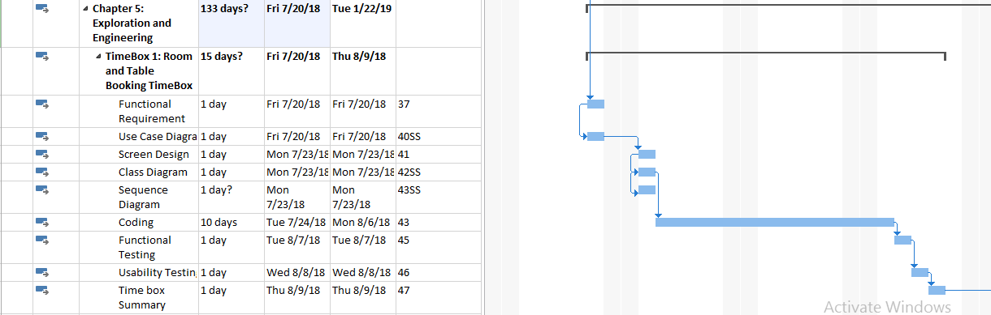

### 5.1.1 Functional Requirements

### 5.1.2 Use Case Diagram



**Use Case Description**

|  |  |
| --- | --- |
| **Use Case Name** | Record Customer |
| **Actor** | Receptionist |
| **Flow of Event** | Fill the customer details in the customer form. Register button is clicked. |

For remaining, see Appendix.

### 5.1.3 Screen Design

1. **Customer Register Form**

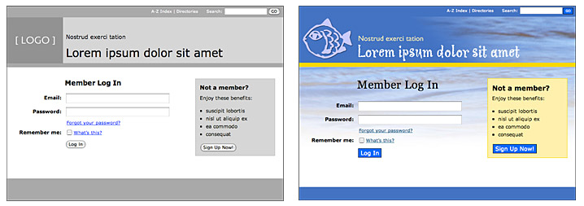

Fig (1) Low Level Prototype for Customer Registration



Fig (2) High Level Prototype for Customer Registration

### 5.1.4 Iteration for Screen Design

**Iteration 1**

Users tell that table form and room form design are needed to change. So, table style combo box is added in table entry form and room size combo box and Facility text box is also added in room form.

**(Iteration 1) Screen Design for Customer Register Form**

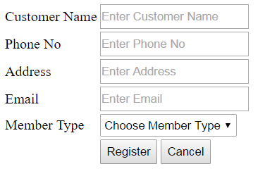

### 5.1.5 Class Diagram

#### Initial Class Diagram

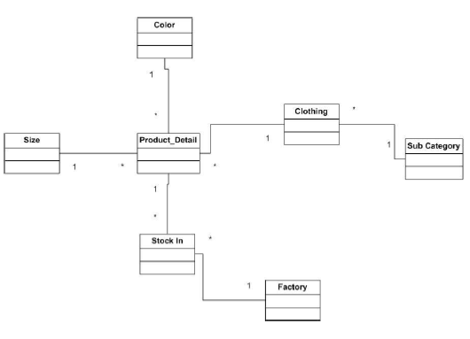

#### Detailed Class Diagram

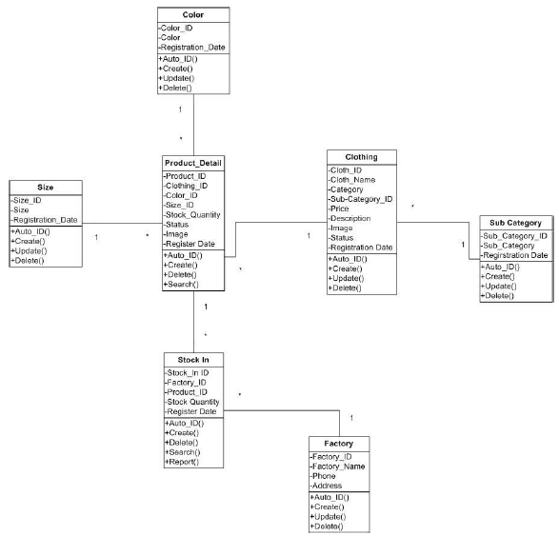

**Detail Class Definitions**

|  |  |
| --- | --- |
| **Class Name** | Customer |
| **Attributes** | Customer ID, Customer Name, Phone No, Address, Email, Member Type |
| **Operation** | Register (),Cancel (), AutoID(), Checkdata() |
| **Description** | << The **Customer** class is used to do register for customers who booked.>> |

For remaining, see Appendix.

### 5.1.6 Sequence Diagram for Booking Process



**Sequence Diagram Description**

### 5.1.7 Functional Testing

#### Test Plan

**Module 1: Customer Entry**

|  |  |  |  |
| --- | --- | --- | --- |
| Test Script | Description | Date | Tester |
| 1.1 | Test customer Name text box | 7- August- 2018 | Kyal Sin Linn |
| 1.2 | Test Customer Phone no text box | 7- August- 2018 | Kyal Sin Linn |
| 1.3 | Test Customer Address text box | 7- August- 2018 | Kyal Sin Linn |
| 1.4 | Test the ‘@’ in the E mail | 7- August- 2018 | Kyal Sin Linn |
| 1.5 | Test Customer Email text box | 7- August- 2018 | Kyal Sin Linn |
| 1.6 | Test Register Button | 7- August- 2018 | Kyal Sin Linn |

#### Test Script (1)

|  |  |  |  |  |
| --- | --- | --- | --- | --- |
| **Unit Test 1** | | **Test Case:** Register by data entry customers | **Designed by:** Mg Mg | |
| **Data Source:** Customer register Form | | **Objective**: To test the Register of data entry customers | **Tester**: Mg Mg | |
| **Test Case** | **Description** | **Test Procedure** | **Expected Result** | **Actual Results** |
| 1.1 | Testing the complete Register of data entry customer | 'Register' button is clicked. Customer Name is blanked. | Show ‘Please fill out this field’ message. | See Fig.1.2 |

Before Testing

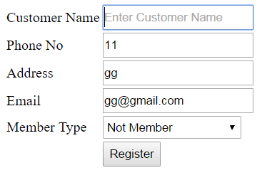

Fig.1.1

After Testing

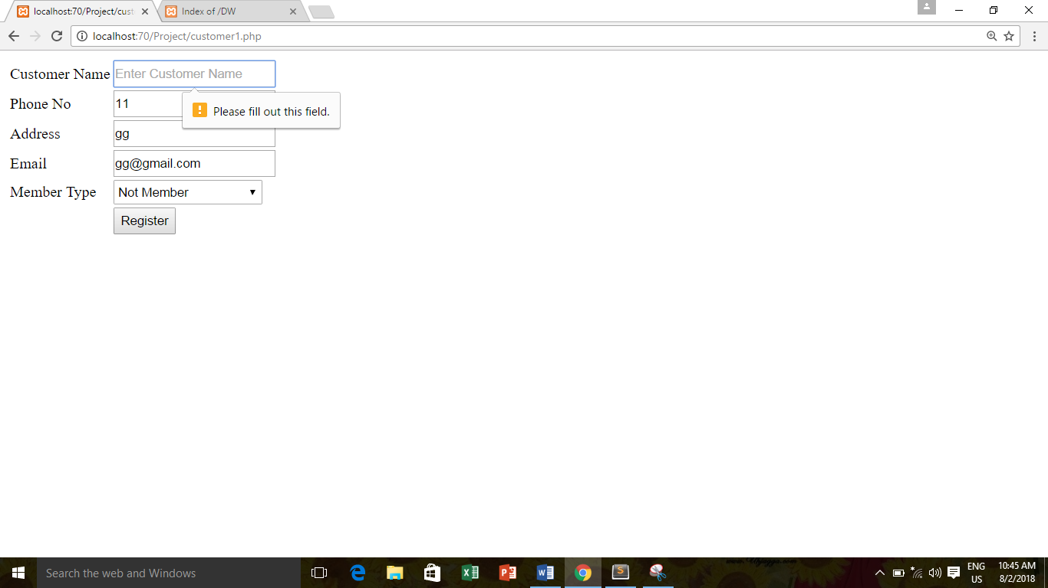

Fig.1.2

**For remaining test cases, please see Appendix.**

### 5.1.8 Usability Testing

#### Visibility of System Status

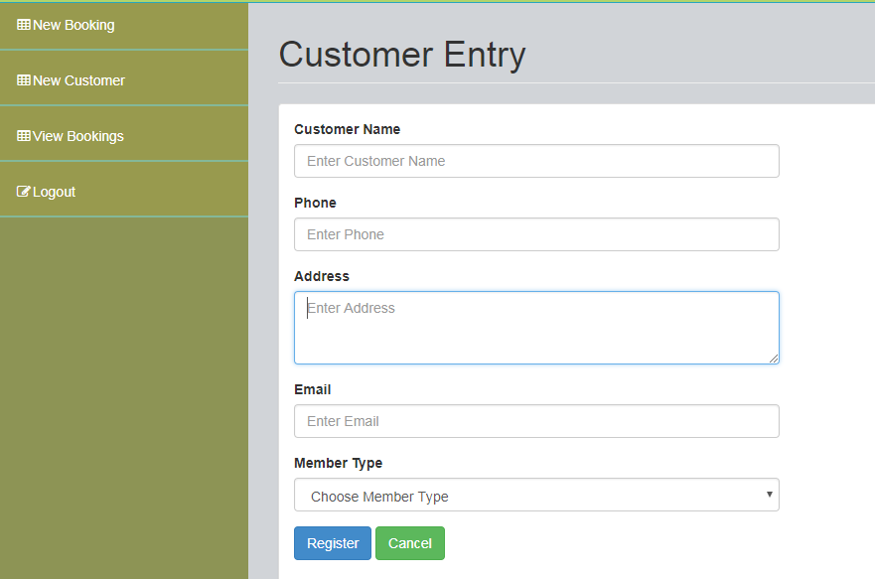

Can see text box with different color

Explain

#### Match between System and Real World

FASDF

#### Aesthetic and Minimalist Design

ASDF

#### Consistency and standard

ASDF

#### Error Prevention

SDFDFS

#### User Control and Freedom

ASDF

### 5.1.9 Iteration for Usability Testing

**Iteration 2**

Users tell that table form and room form design are needed to change. So, table style combo box is added in table entry form and room size combo box and Facility text box is also added in room form.

**(Iteration 2) Iteration For Visibility of System Status**

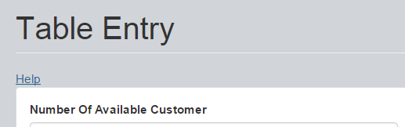

Click to the help link

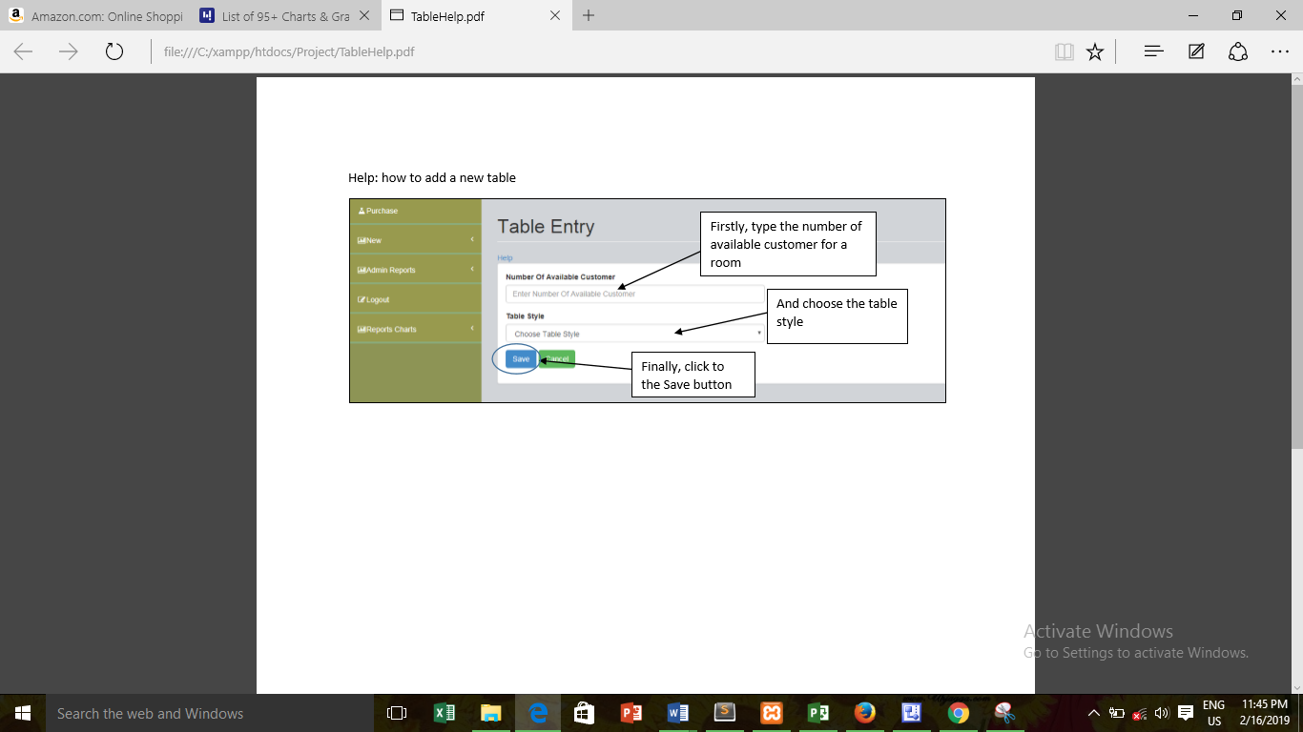

### 5.1.8 Time box Summary

ASDF

### 

CHAPTER – 6

Deployment

## 6.1 Deployment

### 6.1.1 Deployment Diagram



### 6.1.2 Explanation for diagram

ASDFASDFDF

## 6.2 Data Migration

### 6.2.1 Data to Migrate

|  |  |  |
| --- | --- | --- |
| Time Box | Master Data | Transaction Data |
| **Time Box 1: Table and Room Booking Time Box** | Customer, Staff, Room, Table | Booking |
|  |  |  |
|  |  |  |
|  |  |  |

### 6.2.2 Plan

|  |  |  |  |  |  |
| --- | --- | --- | --- | --- | --- |
| TimeBox | Data To Migrate | Duration | Start Date | End Date | Responsible person |
| **Time Box 1: Room and Table Booking Time Box** | * Customer * Staff * Room * Table * Booking | 4 days | 9 August 2018 | 14 August 2018 | Receptionist,  Restaurant Manger |
|  |  |  |  |  |  |
|  |  |  |  |  |  |
|  |  |  |  |  |  |

## 6.3 Training

### 6.3.1 Training plan

|  |  |  |  |  |  |  |
| --- | --- | --- | --- | --- | --- | --- |
| No | Contact | Trainer | Start Date | End Date | Venue | Time |
| 1 | Time Box 1   * Customer * Room * Table * Booking * Staff | Receptionist, Restaurant Manager, | 15 August 2018 | 17 August 2018 | Jame Restaurant | 5 pm – 7 pm |
|  |  |  |  |  |  |  |
|  |  |  |  |  |  |  |
|  |  |  |  |  |  |  |

### 6.3.2 User Manual

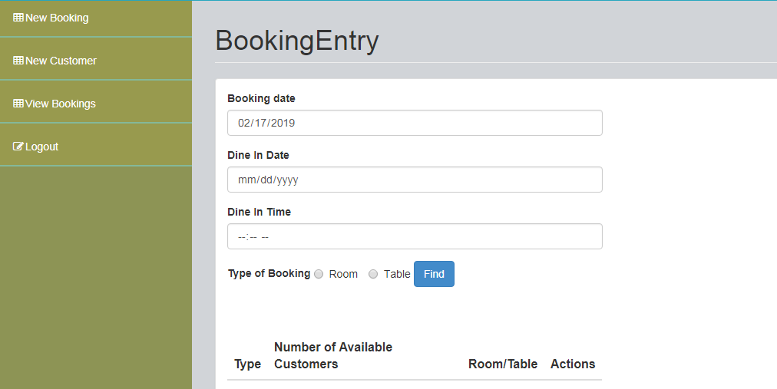

Firstly, set the booking date

And set the booking time

After choosing the booking type click to the Find button

And Choose the booking type

### CHAPTER – 7

### CONCLUSION

### &

### EVALUATION

## 7.1 Evaluation against Aim & Objectives

### Aim

### Objective 1

Analysis –

### Objective 2

Design –

### Objective 3

Coding –

### Objective 4

Testing –

### Objective 5

Training –

## 7.2 Evaluation Against Similar System

|  |  |  |
| --- | --- | --- |
| No | My System | Incy POS |
| 1 | Visibility of System Status    The system status the selected text box in the specific color so the status of the system is said to be visible. | Visibility of System Status  C:\Users\Kyal Sin Linn\Pictures\App\Screenshot_20180713-163444.jpg  The system status the selected tab in the specific style so the status of the system is said to be visible. |
|  |  |  |
|  |  |  |
|  |  |  |
|  |  |  |
|  |  |  |
|  |  |  |

## 7.3 Evaluation against Justification Made

#### Method

#### Language

#### Database

## 7.4 Evaluation against Time Box Plan

#### Time Box 1: Room and Table Booking Time Box

When making the time box plan, the end date for time box 1 is ‘August 9, 2018’. And time box 1 was finished with all the needed iteration within this date. Therefore, end date was matched with time box plan.

## 7.5 Personal Evaluation

## 7.6 Strength & Weakness

Strength

Weakness

## 7.7 Future Amendment

### 

### APPENDIX

## Section A: Use Case Descriptions

### Timebox 1: Room and Table Booking Timebox

## Section B: Detailed Class Definitions

### Timebox 1: Room and Table Booking Timebox

## Section C: Coding

|  |  |  |
| --- | --- | --- |
| Form | Function | Purpose |
| Ingredient Entry, Table Entry, Room Entry, Food Entry, | Save () | To save the data from the forms into the database. When SAVE button is clicked the input data are loaded into variables and then using sql statements, inserting is made. |
|  |  |  |
|  |  |  |
|  |  |  |
|  |  |  |

## Section D: Test Scripts

## Section F: Interview Scripts

When interview with manager

References

**References List**